

Grade Ruan School
Lizard Schools Curriculum
Subject: MFL

We are committed to providing a curriculum that is underpinned by three essential drivers: aspiration, curiosity, and diversity. We aim to empower our learners to develop the knowledge, skills, and values they need to not only succeed in their education but also to become successful global citizens. Through our rigorously and consciously crafted curriculum, we teach clear sequences of enquiry-based learning encompassing the National Curriculum, reflecting the unique and special part of the world in which we live. We believe in helping our children flourish, realising their full potential, and fostering a caring and nurturing community where every child is valued.

Our MFL Concepts

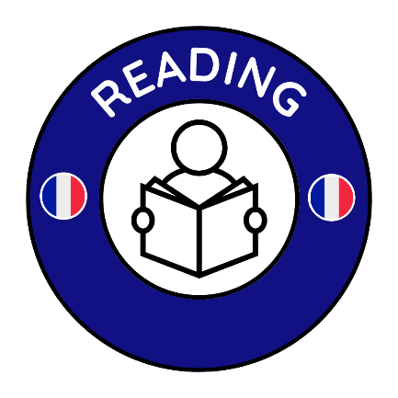

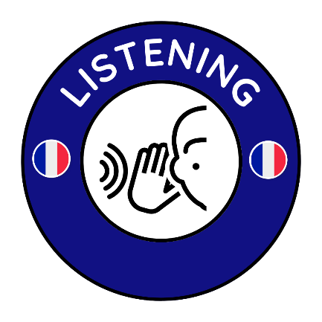
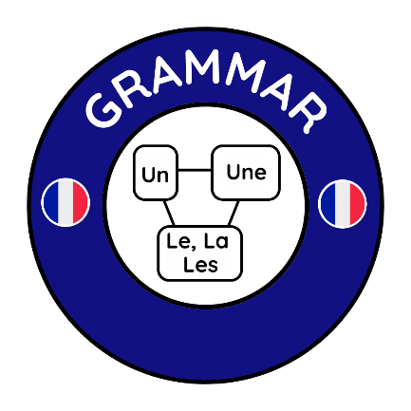

Curriculum Overview
KS2
Key Stage 2 CYCLE 1
AUTUMN | SPRING | SUMMER
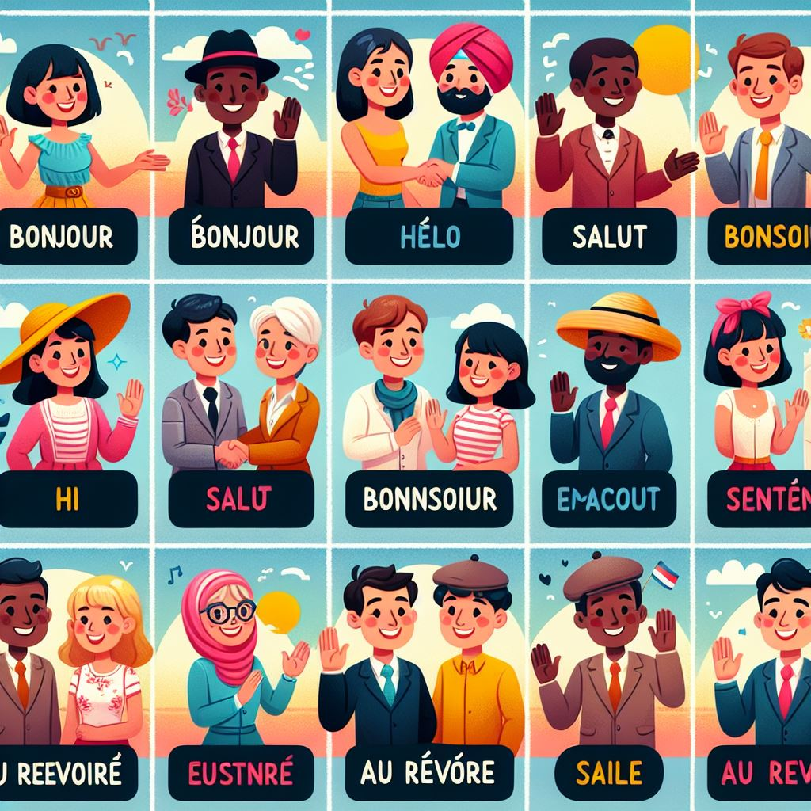  What do you want to know?  - Greetings.  - Hello from France.  - How are you?  - Showtime!  - To understand and exchange written information. |   What’s in the classroom?  - Days of the week.  - A French maths lesson.  - A French school timetable?  - What is in your classroom?  - School life. |   Am I invited?  - Numbers 1-31.  - Months of the year.  - Seasons and dates.  - Celebrating a French birthday.  - Birthdays on France.

Key Stage 2 CYCLE 2
AUTUMN | SPRING | SUMMER
  Will colour help me learn?  - Colourful connections.  - Meet the animals.  - Nouns and colour adjectives.  - Animal portraits.  - At the art gallery. | 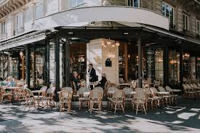  Are you ready to order?  - Ordering food and drink in in a French café.  - Managing money in French.  - French shops.  - French food.  - French food – le menu. | 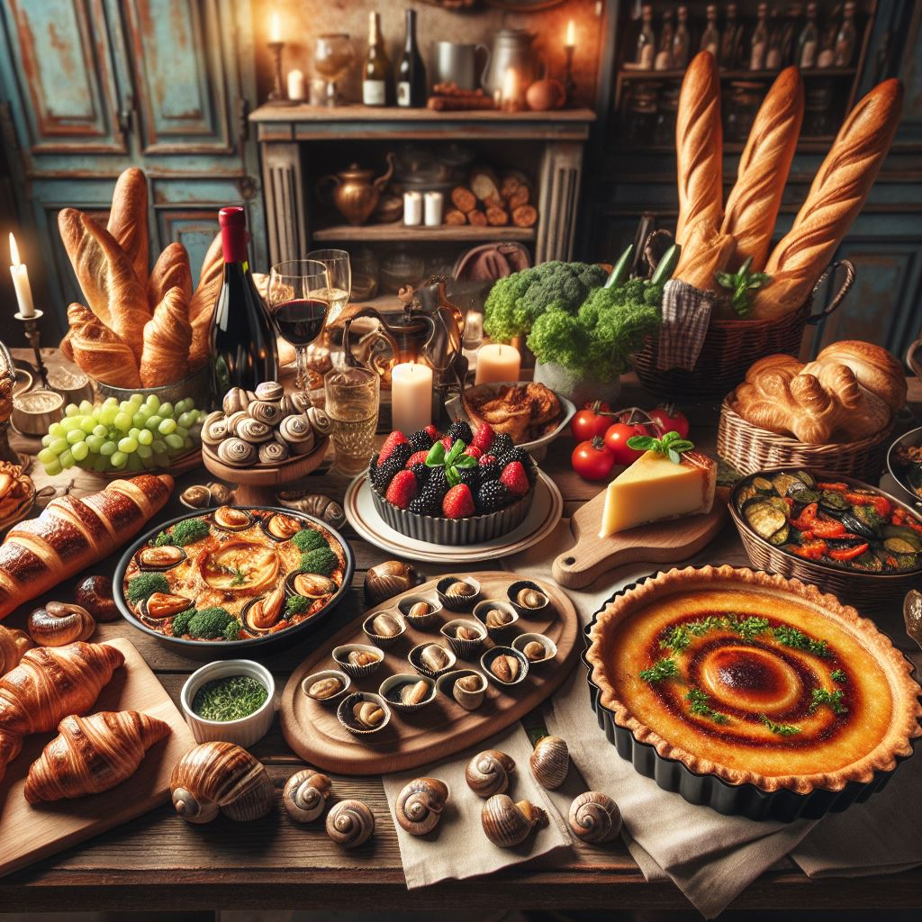  How much is enough?  - Favourite French foods.  - Regional French food.  - Monsieur Mangetout’s French food week.  - Shopping in France – how much?  - French detectives in the kitchen.

KS2 Skills  Coverage | Cycle 1  Autumn | Cycle 1  Spring | Cycle 1  Summer | Cycle 2  Autumn | Cycle 2  Spring | Cycle 2  Summer
Culture
Grammar
Listening
Reading
Speaking

